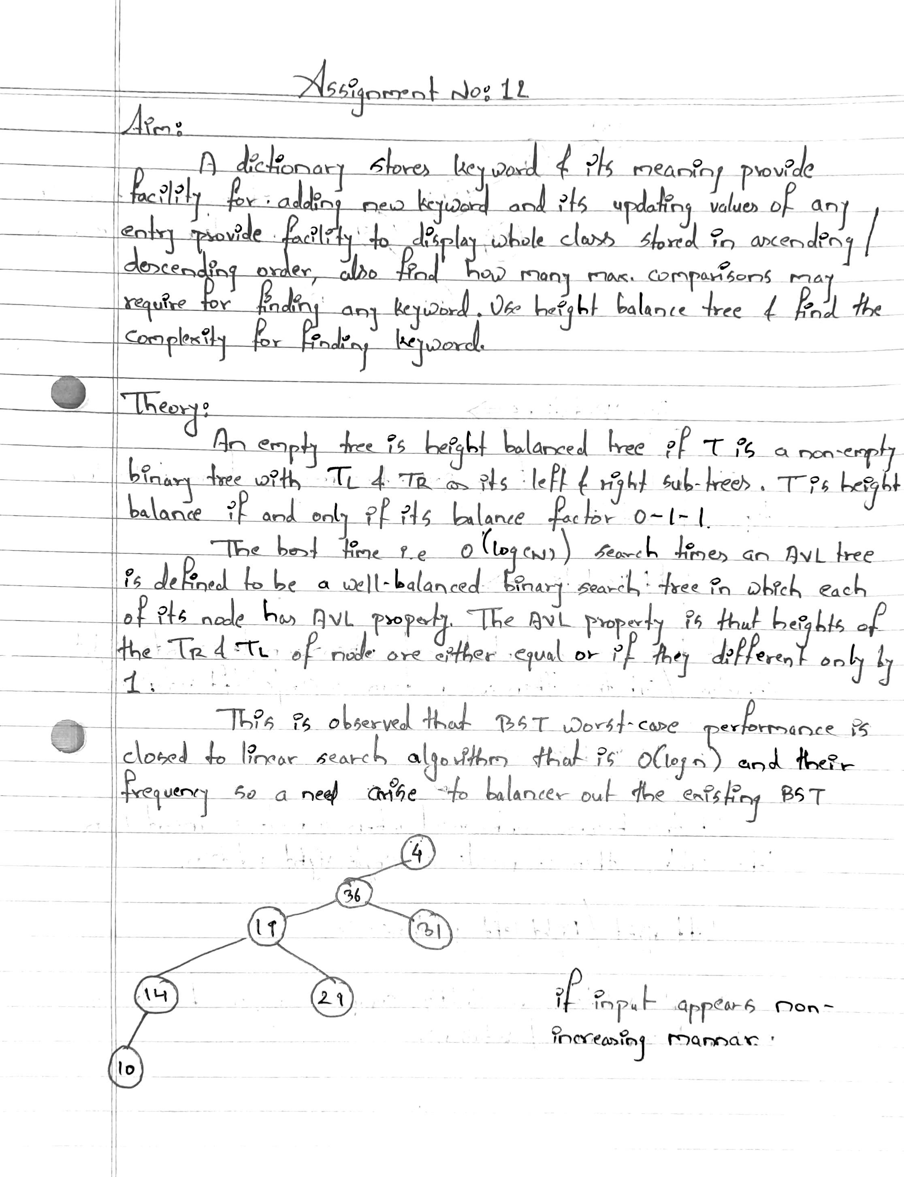

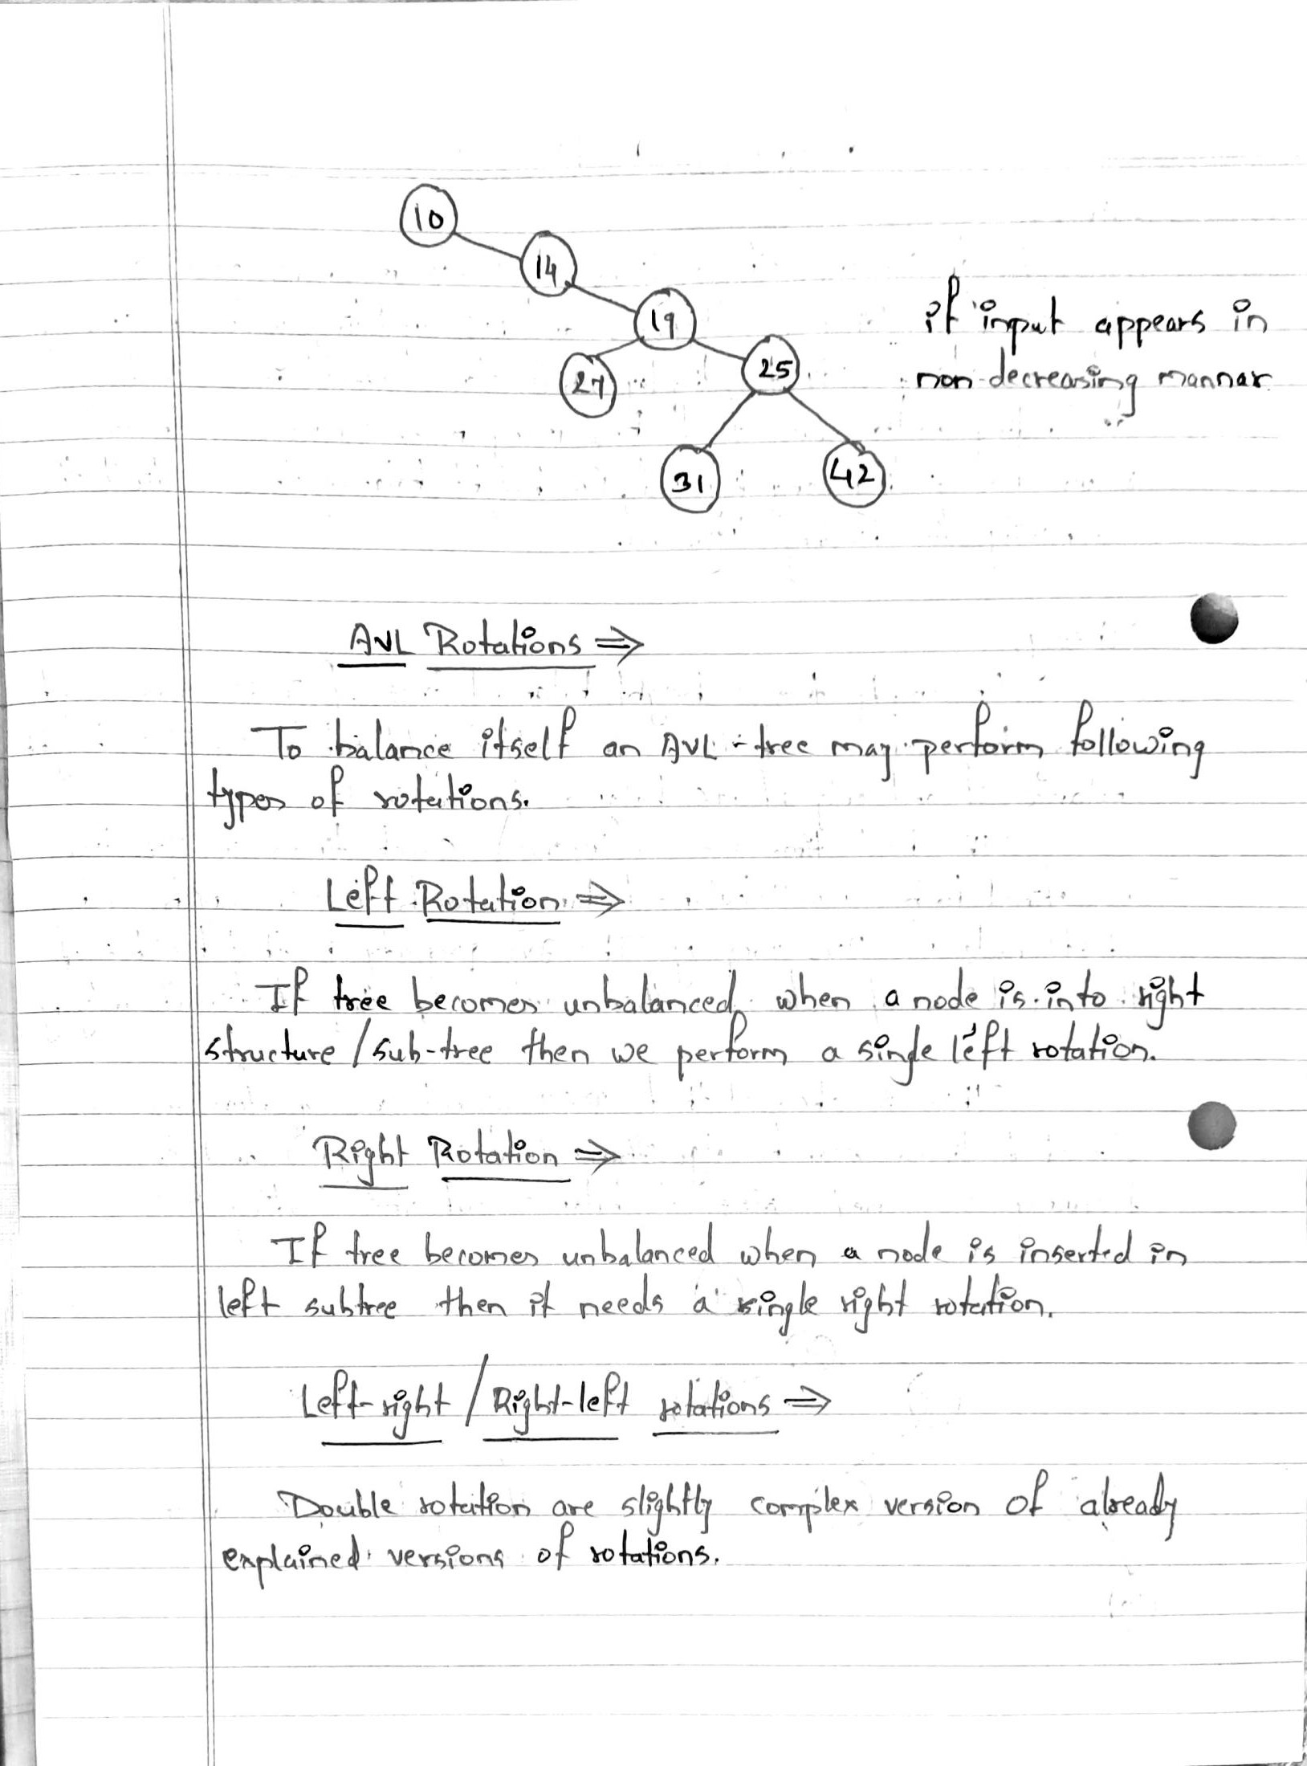

Program Code :-

#include <iostream>

#include <string.h>

using namespace std;

typedef struct node

{

char k[20];

char m[20];

class node \*left;

class node \*right;

} node;

class dict

{

public:

node \*root;

void create();

void disp(node \*);

void insert(node \*root, node \*temp);

int search(node \*, char[]);

int update(node \*, char[]);

node \*del(node \*, char[]);

node \*min(node \*);

};

void dict ::create()

{

class node \*temp;

int ch;

do

{

temp = new node;

cout << "\nEnter Keyword:";

cin >> temp->k;

cout << "\nEnter Meaning:";

cin >> temp->m;

temp->left = NULL;

temp->right = NULL;

if (root == NULL)

{

root = temp;

}

else

{

insert(root, temp);

}

cout << "\nDo u want to add more (y=1/n=0):";

cin >> ch;

} while (ch == 1);

}

void dict ::insert(node \*root, node \*temp)

{

if (strcmp(temp->k, root->k) < 0)

{

if (root->left == NULL)

root->left = temp;

else

insert(root->left, temp);

}

else

{

if (root->right == NULL)

root->right = temp;

else

insert(root->right, temp);

}

}

void dict::disp(node \*root)

{

if (root != NULL)

{

disp(root->left);

cout << "\n Key Word :" << root->k;

cout << "\t Meaning :" << root->m;

disp(root->right);

}

}

int dict ::search(node \*root, char k[20])

{

int c = 0;

while (root != NULL)

{

c++;

if (strcmp(k, root->k) == 0)

{

cout << "\nNo of Comparisons:" << c;

return 1;

}

if (strcmp(k, root->k) < 0)

root = root->left;

if (strcmp(k, root->k) > 0)

root = root->right;

}

return -1;

}

int dict ::update(node \*root, char k[20])

{

while (root != NULL)

{

if (strcmp(k, root->k) == 0)

{

cout << "\nEnter New Meaning ofKeyword" << root->k;

cin >> root->m;

return 1;

}

if (strcmp(k, root->k) < 0)

root = root->left;

if (strcmp(k, root->k) > 0)

root = root->right;

}

return -1;

}

node \*dict ::del(node \*root, char k[20])

{

node \*temp;

if (root == NULL)

{

cout << "\nElement No Found";

return root;

}

if (strcmp(k, root->k) < 0)

{

root->left = del(root->left, k);

return root;

}

if (strcmp(k, root->k) > 0)

{

root->right = del(root->right, k);

return root;

}

if (root->right == NULL && root->left == NULL)

{

temp = root;

delete temp;

return NULL;

}

if (root->right == NULL)

{

temp = root;

root = root->left;

delete temp;

return root;

}

else if (root->left == NULL)

{

temp = root;

root = root->right;

delete temp;

return root;

}

temp = min(root->right);

strcpy(root->k, temp->k);

root->right = del(root->right, temp->k);

return root;

}

node \*dict ::min(node \*q)

{

while (q->left != NULL)

{

q = q->left;

}

return q;

}

int main()

{

int ch;

dict d;

d.root = NULL;

do

{

cout << "\nMenu\n1.Create\n2.Disp\n3.Search\n4.Update\n5.Delete\nEnter Ur CH:";

cin >> ch;

switch (ch)

{

case 1:

d.create();

break;

case 2:

if (d.root == NULL)

{

cout << "\nNo any Keyword";

}

else

{

d.disp(d.root);

}

break;

case 3:

if (d.root == NULL)

{

cout << "\nDictionary is Empty. First add keywords then try again ";

}

else

{

cout << "\nEnter Keyword which u want to search:";

char k[20];

cin >> k;

if (d.search(d.root, k) == 1)

cout << "\nKeyword Found";

else

cout << "\nKeyword Not Found";

}

break;

case 4:

if (d.root == NULL)

{

cout << "\nDictionary is Empty. First add keywords then try again ";

}

else

{

cout << "\nEnter Keyword which meaning want to update:";

char k[20];

cin >> k;

if (d.update(d.root, k) == 1)

cout << "\nMeaning Updated";

else

cout << "\nMeaning Not Found";

}

break;

case 5:

if (d.root == NULL)

{

cout << "\nDictionary is Empty. First add keywords then try again ";

}

else

{

cout << "\nEnter Keyword which u want to delete:";

char k[20];

cin >> k;

if (d.root == NULL)

{

cout << "\nNo any Keyword";

}

else

{

d.root = d.del(d.root, k);

}

}

}

} while (ch <= 5);

return 0;

}

Program Output:-

